|  |
| --- |
| Summer 2017  Probability 6600 |
| **Kaitlin Graham kgraham@stphilipsbemidji.org Tim Slough**  **tim_slough@isd31.net**  **Janelle Saiger**  **janelle_saiger@isd31.net**  philipsbemidji.org |
|  |

Summary

Our 15-day unit is designed to explore probability, organizing data, and graphing. This unit aligns with the MN K-12 Standard for 3rd Grade Data Analysis.

**Data Analysis**: Collect, organize, display, and interpret data. Use labels and a variety of scales and units in displays. 3.4.1.1 Collect, display and interpret data using frequency tables, bar graphs, pictures graphs and number line plots having a variety of scales. Use appropriate titles, labels and units.

The goal of this unit is to provide students with multiple differentiated strategies to understand probability, organizing data, and graphing. They will also be able to make inferences and conclusions from the data they have collected or been given. They will do this by displaying the data in charts and graphs. Students will have the opportunity to gather data themselves and show that they can collect data in an effective way. This unit will have a pre-and post-test. The expectation of the post-test is to see that the students have gained knowledge and the ability to apply these skills.

Resources for work pages were found on teacherspayteachers.com, from Progress in Mathematics text book, mathwire.com, Pinterest, or were created from a mix of both.

**MCA Question Addressed:**

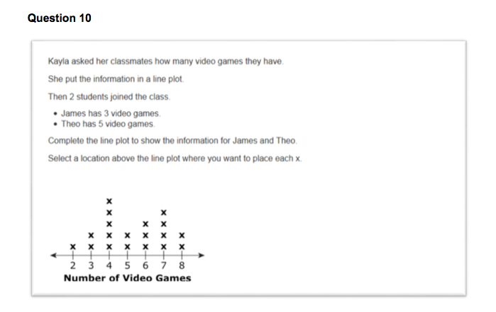

Table of Contents

**Pre-Test** (1 Day) Page 38-39

**What Suit Is It?** (1 Day) Page 5

Card Probability

**Derby Race** (1 Day) Pages 6-11

Probability Game and reviewing tally marks

**Tally Charts** (2 Days) Pages 12-15

Day 1: What is a Tally Chart? Reading a Tally Chart

Day 2: Probability Activity “Grab Bag” & make a Tally Chart

**Pictographs** (2 Days) Pages 16-20

Day 1: What are Pictographs? Reading a Pictograph

Day 2: Take a survey & make a Pictograph

**Bar Graphs** (2 Days) Pages 21-25

Day 1: What are Bar Graphs? Reading a Bar Graph

Day 2: Flip Coins & make a Bar Graph

**Spinner Game** (3 Days) Pages 26-29

Day 1: Equally Likely

Day 2: Not Equally Likely

Day 3: Show understanding of Equally Likely & Not Equally Likely

Table of Contents

**Line Plots** (2 Days) Pages 30-33

Day 1: What are line plots? – Reading a line plot

Day 2: Probability Activity “Roll Dice” – record data & make a Line Plot

**M & M Graphing** (1 Day) Pages 34-36

Review – Review Equally Likely, Not Likely, Tally Charts, Pictographs, and Bar Graphs

**Prodigy Day** (1 Day) Page 37

Play Prodigy with the assignment set to data relationships

**Post Test** (1 Day) Pages 38-39

**Card Probability – What Suit Is It?**

**Standard: Grade 3:** Data Analysis: Collect, organize, display, and interpret data. Use labels and a variety of scales and units in displays. 3.4.1.1 Collect, display and interpret data using frequency tables, bar graphs, pictures graphs and number line plots having a variety of scales. Use appropriate titles, labels and units.

**Launch-** Take out a deck of cards. Talk about the different parts of a deck of cards, number of cards, suits, colors, face cards, etc. Ask the students how many have played with a deck of cards and what kind of games? Today we are going to give everyone a card that will be red or black with a classmate’s name on it. (Don’t let them look at the card yet.)

**Explore –** Shuffle the deck in front of the students, have a student cut the deck. Then hand out a card to each student face down. (Again, don’t allow them to look at the card yet.) They need to predict what color they think their card will be and will it be a boy or girl. (To make it more challenging they could predict whose name they think will be on the card.) Have a simple chart on the board/chart paper to organize the data of predictions with a spot that shows if they predicted correctly. Do this one student at a time after you have recorded one student’s prediction they can look at the card right away to see if they predicted correctly.

**Share –** Put the students in groups of 3-4 and have them share their predictions. Have them discuss what was easy to predict and what was more difficult.

**Summarize –** Come together as a whole group and discuss why some things were easier to predict than others. Discuss how the data was organized and if it was easy to read how we organized our data.

**Derby Race**

**Standard: Grade 3:** Data Analysis: Collect, organize, display, and interpret data. Use labels and a variety of scales and units in displays. 3.4.1.1 Collect, display and interpret data using frequency tables, bar graphs, pictures graphs and number line plots having a variety of scales. Use appropriate titles, labels and units.

**Launch-** Take a vote on how many kids know what a horse race is. Explain to them that a horse race or horse derby is a contest to see which horse is the fastest. People get make a prediction on who they think will win before the race starts. Today we are going to play a game called Derby Race. There are 6 horses in this race. You can only pick one horse that you think will be the winner. Every time a horse wins you will keep track with a tally mark. (Review what tally marks are and what happens when they get to five.) For a horse to win it must get to the other side of the game board. To get a horse to move you must roll the dice on your turn. Subtract the two numbers on your dice for example if you roll a 6 and a 2 you will do 6-2=4. So, horse 4 will get to move forward even if that is not the horse you predicted to win. You must make your prediction before the game starts, and you cannot change your mind! Your group will play the game 10 times.

**Explore –** Split the class into groups of 2-6. (2-6 students can play the game – decide what will work best for your classroom – I prefer groups of 2 for this game because one person can roll the dice and the other can record.) Each group will need one game board, two dice, 6 markers (ex: bingo dot, paper clip, etc.) and one record sheet.

**Share –** After every group has finished their 10 games come together as a whole group. Share results from each group.

**Summarize –** Discuss which horse each group found won the most. Was there a horse that never won? Did all horses have an equally likely chance of winning? How do we know if they had an equally likely chance of winning (get into the combinations of dice they could have rolled to show the probability of each horse’s chances of winning.)

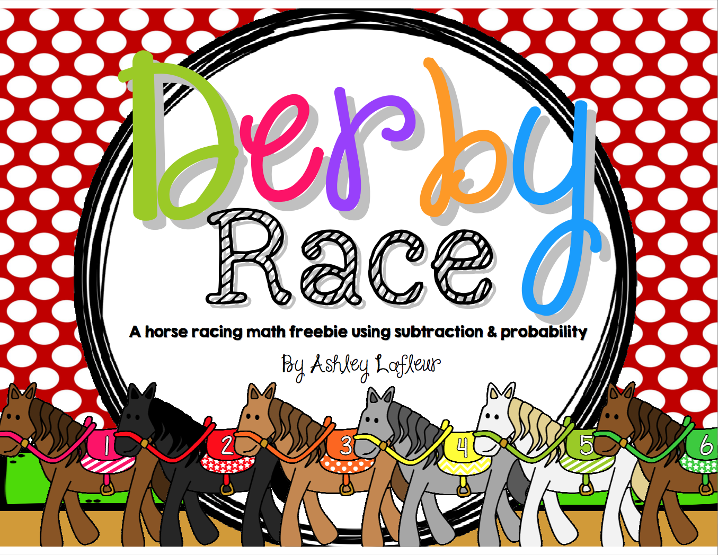

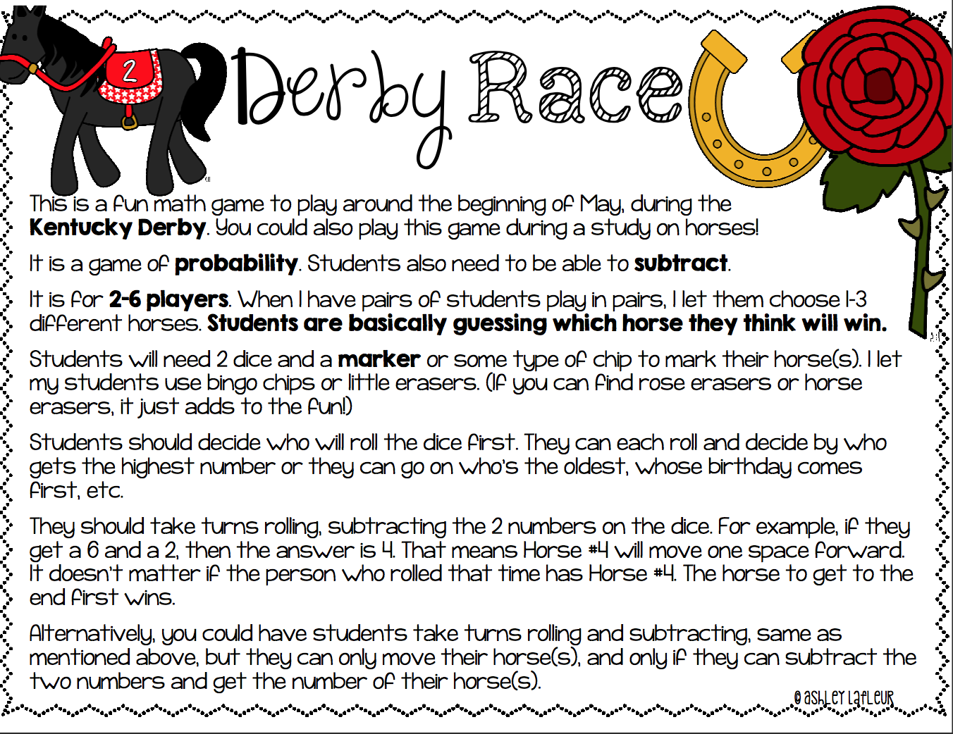

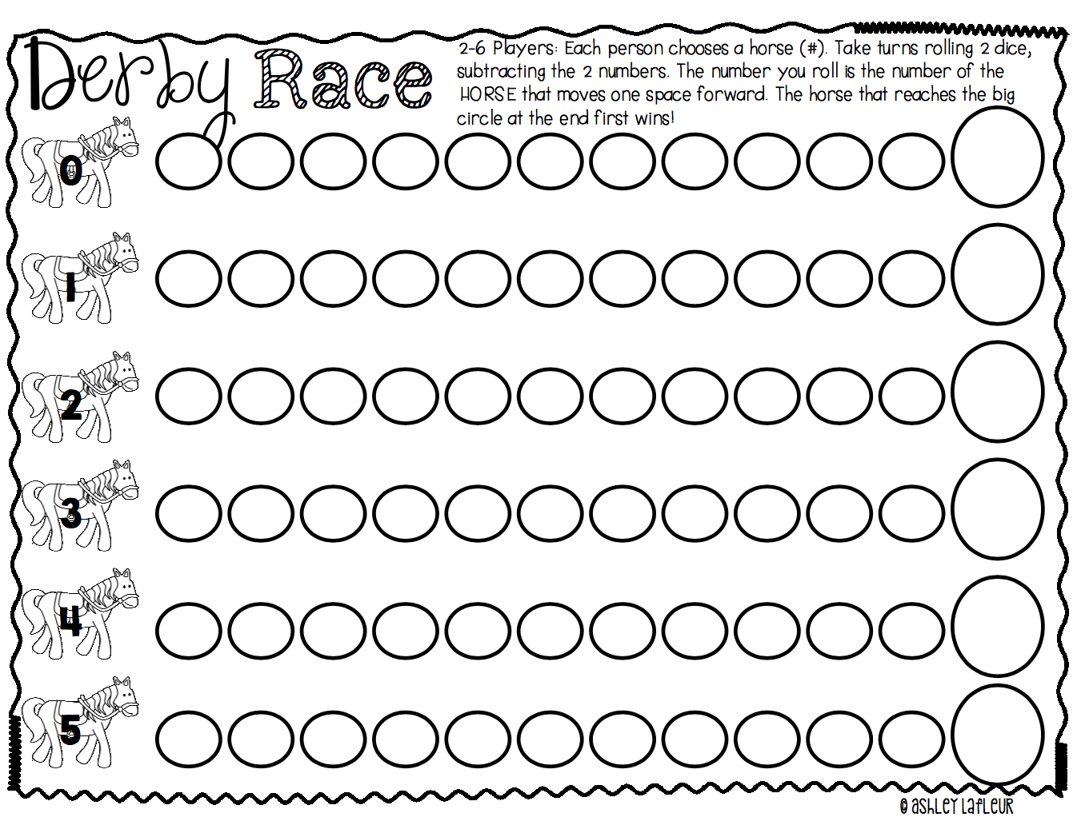

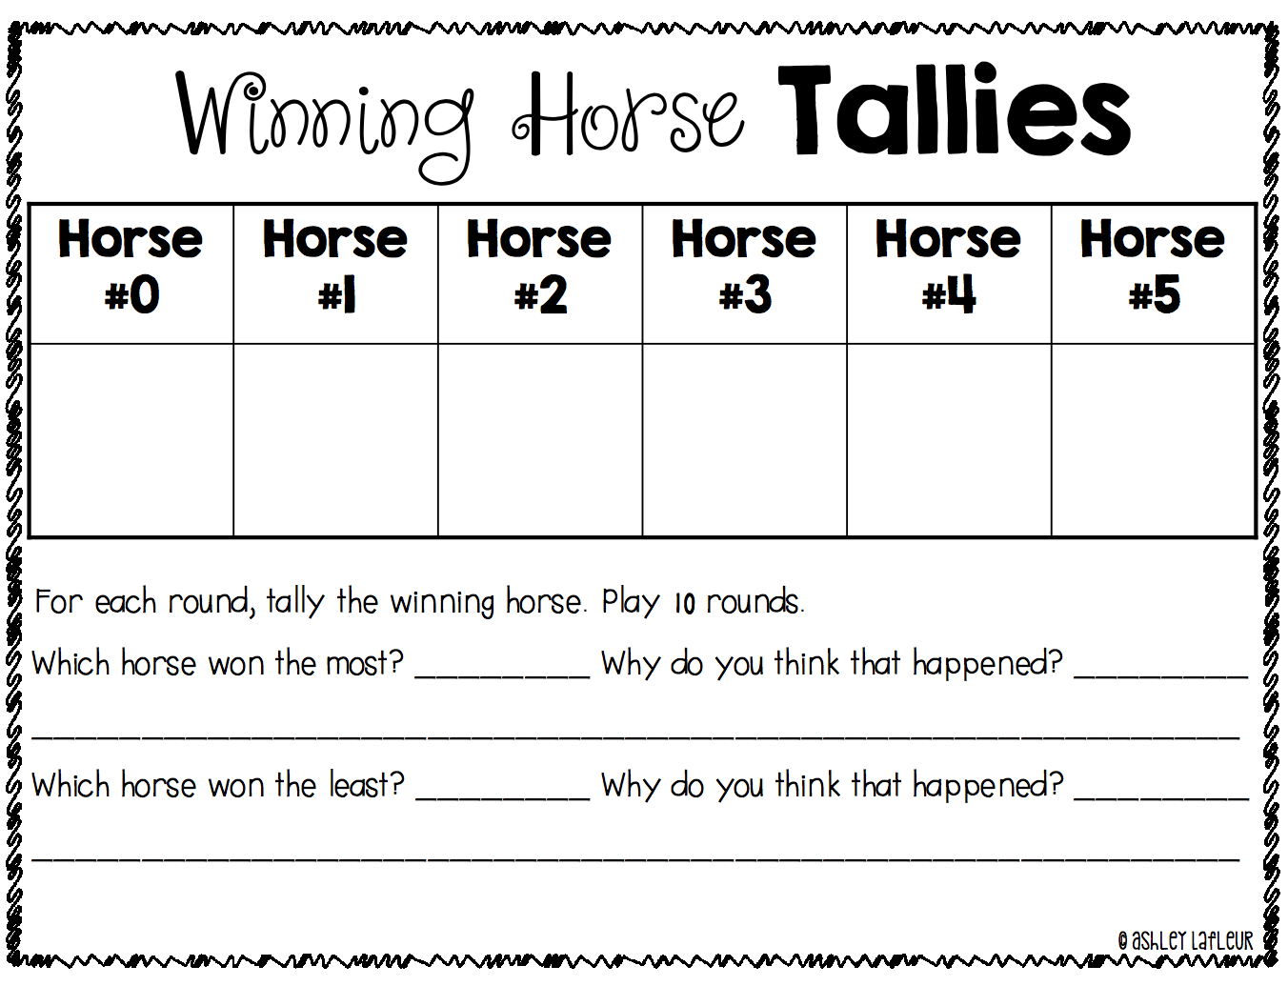

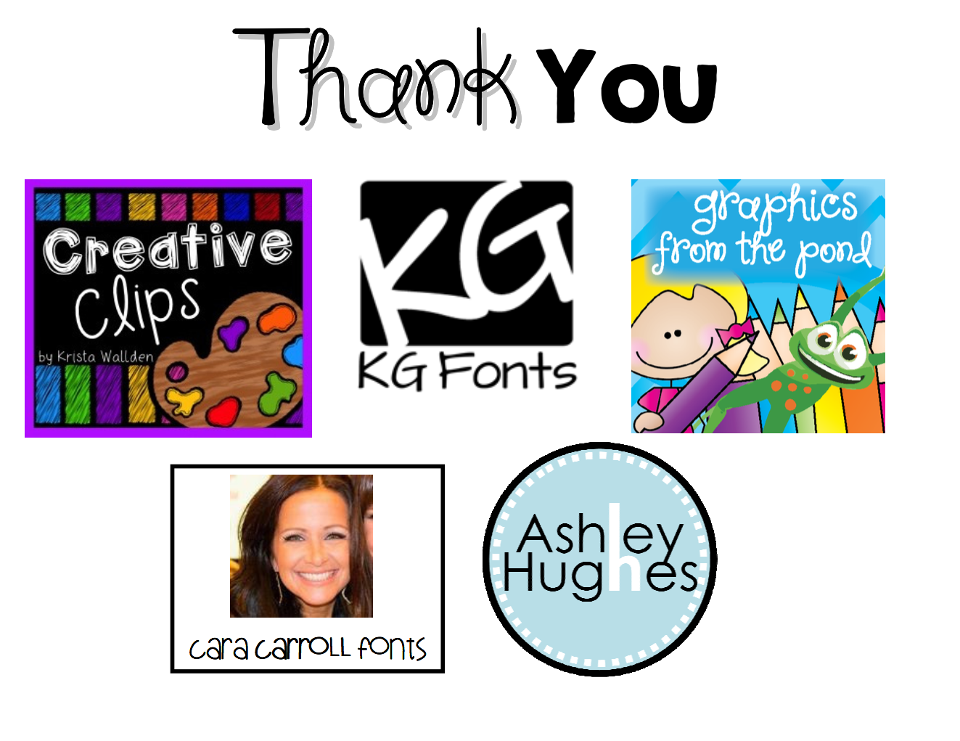

**Tally Charts**

**Standard: Grade 3:** Data Analysis: Collect, organize, display, and interpret data. Use labels and a variety of scales and units in displays. 3.4.1.1 Collect, display and interpret data using frequency tables, bar graphs, pictures graphs and number line plots having a variety of scales. Use appropriate titles, labels and units.

**Launch- Day 1:** Start out by reading the book Tally O’Mally by Stuart Murphy. After reading the story talk about what they saw and what they think we will be learning about today. Hand every student a sticky note to write on. On their sticky note have them write what month and day their birthday is and stick them on the white board when they are done. Discuss if we can tell what month has the most birthdays? What would be a better way to organize this information so it is easier to understand? (Hopefully someone will say tally marks but if not lead them that way).

**Day 2:** Review the important labels that belong on a tally chart. Tell the students that today they are going to each make their own tally chart while playing a game called “Grab Bag”. Each bag will have 5 red squares and 5 blue squares. When you pull out a piece your partner will record the data on a tally chart. Then you put the square back in the bag and shake it up. Do not look when you are pulling, it should be a surprise when you pull out your square! Remind them about the vocabulary of equally likely and not equally likely, and if each bag has 5 red and 5 blue what is the probability? (Equally likely or not equally likely?)

**Explore- Day 1:** As a whole group explore what a tally chart looks like (make a tally chart on chart paper). What parts are important on a tally chart to have labeled? What kinds of questions can we answer based on our data? (Make sure to keep this tally chart for the rest of the unit.) They will answer questions from a tally chart.

**Day 2:** Have students in groups of 2-3. Each group should have a bag with 5 red squares and 5 blue squares, and a sheet to record data and answer questions.

**Share- Day 1:** Go through the tally chart and answer questions like which month has the most birthdays, which month has the least birthdays, what season has the most birthdays, what season has the least birthdays, etc.

**Day 2:** Come back together and compare tally charts. Combine the classes data on a tally chart to show which color was pulled the most. Go through questions on the tally chart.

**Summarize-**  Emphasize that a tally chart is only one way to organize information you are collecting.

**Day 2:** Discuss about the combined results from “Grab Bag” were. Did the results show an equally likely chance?

**Name: ______________________ Date: __________________**

**Directions:** Use this tally chart to answer the questions below.

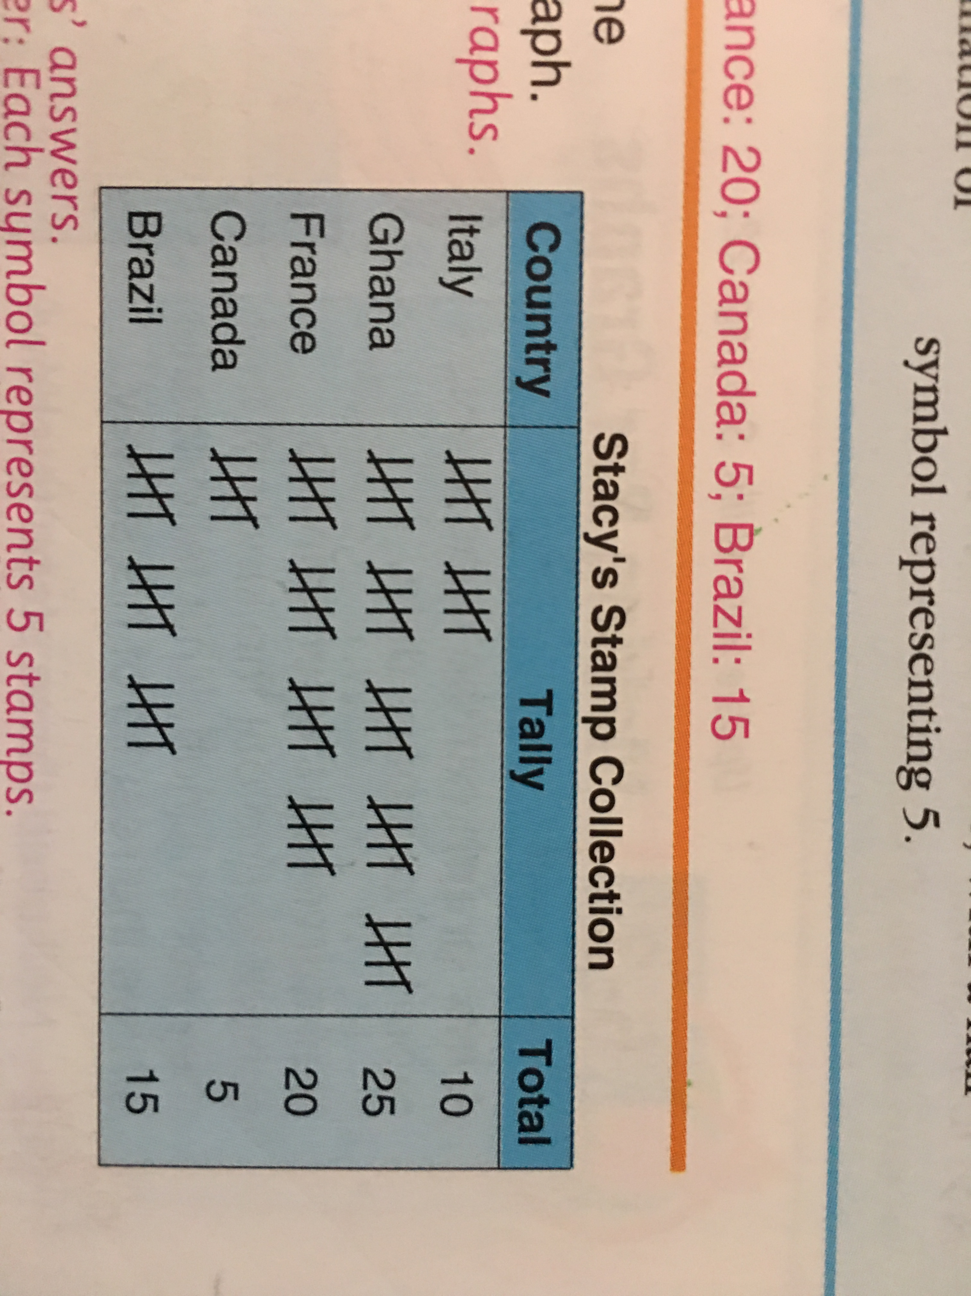

1. **Which country has the most stamps?**
2. **How many more stamps does Stacy have from Brazil than form Canada? (Show your work)**
3. **From which country does Stacy have the least stamps?**
4. **List the countries from the one with the least to the one with the most?**
5. **How many stamps does Stacy have altogether?**

**(Show your work)**

**Name: ______________________ Date: __________________**

**Directions:** Each group member should pull out square 10 times. While one person pulls out squares the other member should record data on your tally chart. Use the space below to make your tally chart. Remember to label your tally chart.

1. **Which color was pulled out the most?**
2. **Which color was pulled out the least?**
3. **Was it equally likely or not equally likely to get red and blue?**
4. **What was the probability to get red?**
5. **What was the probability to get blue?**

**Pictographs**

**Standard: Grade 3:** Data Analysis: Collect, organize, display, and interpret data. Use labels and a variety of scales and units in displays. 3.4.1.1 Collect, display and interpret data using frequency tables, bar graphs, pictures graphs and number line plots having a variety of scales. Use appropriate titles, labels and units.

**Launch- Day 1:** Have your tally chart of birthdays up front so they can see the information. Tell them that they are going to learn another way to organize information. Give each student a birthday candle shape that they can color in whatever color they would like to. Today we are going to learn about pictographs. It is a graph made with pictures to represent data. (Have a graph template ready to go- with blanks for title, key, and birthday months.) On the board on chart paper have your pictograph template up next to your tally chart of birthdays. Fill in the blanks as a whole group – title and birthday months. Explain that pictographs have a key that shows how many each picture is representing. Ask: What will each birthday candle represent on our graph? Discuss how you may have some numbers you don’t want to count by (For example it would be hard count by 5’s if something only has 2.) Fill in the key. Have students come up with their candle and place it on the graph next to their birthday month. (Make sure to keep this pictograph chart for the rest of the unit.)

**Day 2:** Review what a pictograph is, what needs to be included when making a pictograph (title, labels, and key). Have the birthday pictograph visible for those who need a visual. Today they will ask classmates what their eye color is and keep track of their information on a tally chart. Then they will need to make a pictograph with that information and answer questions.

**Explore- Day 1:** Have students answer questions from a completed pictograph to practice reading pictographs and understanding the key.

**Day 2:** Each student will get a sheet to organize their data.

**Share- Day 1:** Come together as a whole group and share what they found out about the questions for their pictograph questions.

**Day 2:** Come together as a whole group and discuss what was found.

**Summarize-**  Compare the tally chart and pictograph. Have students take a vote on which way they like better to have information organized. Get the point across that everyone will feel more comfortable with different ways of having information organized.

Birthday Candle Template

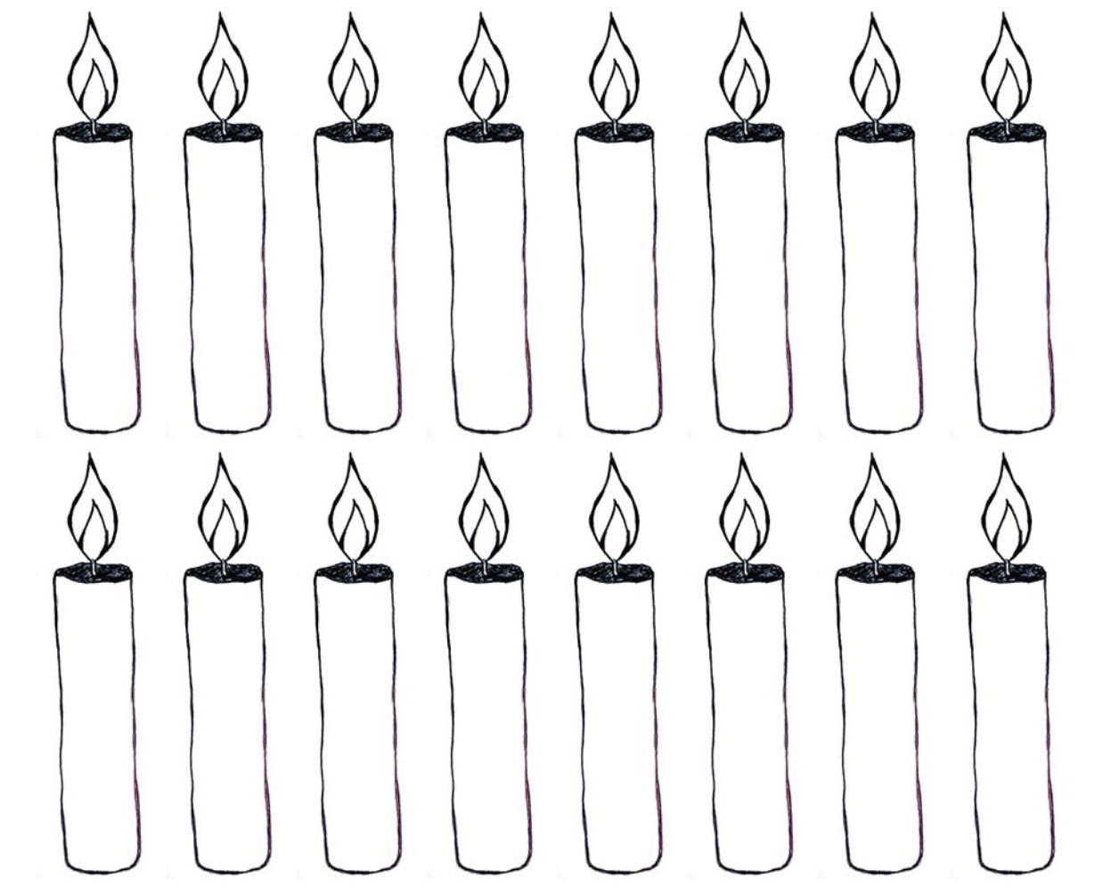

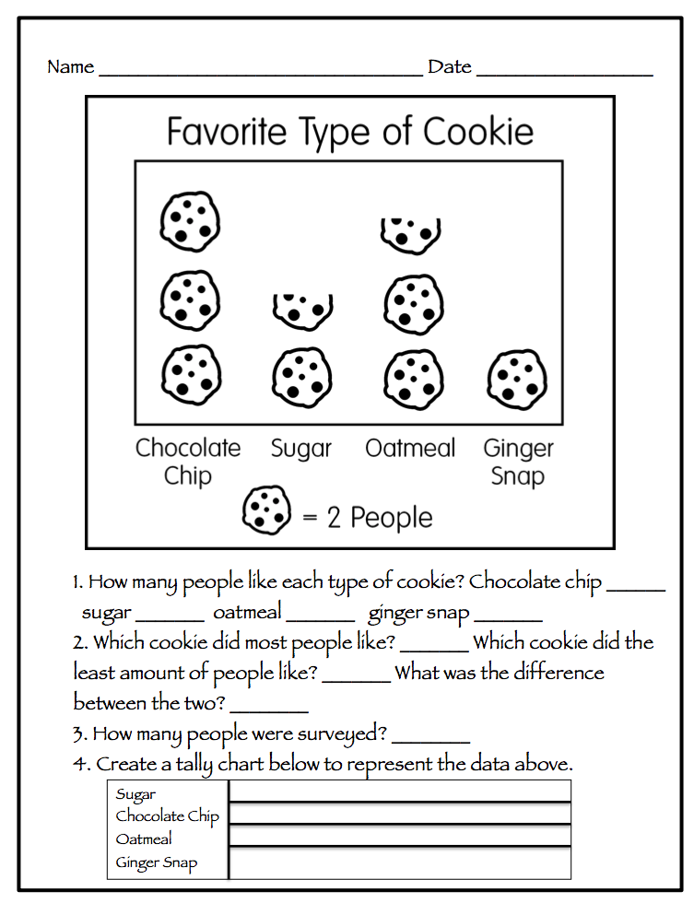

**Name: ____________________ Date: ______________**

**Directions:** Ask your classmates what their eye color is. Keep track on a tally chart and then make a pictograph to show your data. Remember to have a title, labels, and a key.

|  |  |  |
| --- | --- | --- |
| **Eye Color** | **Tally** | **Total** |
| **Blue** |  |  |
| **Green** |  |  |
| **Brown** |  |  |
| **Hazel** |  |  |
| **Other** |  |  |

1. **What eye color is seen the most in our class?**
2. **What eye color is seen the least in our class?**
3. **Is there an eye color that we don’t have in our class?**
4. **How many students have blue eyes + green eyes?**

**(Show your work)**

1. **How many people were surveyed? (Show your work)**
2. **Compare hazel eyes to brown eyes. Which has more? How many more? (Show your work)**
3. **How many eyes are represented by each symbol?**

**Bar Graphs**

**Standard: Grade 3:** Data Analysis: Collect, organize, display, and interpret data. Use labels and a variety of scales and units in displays. 3.4.1.1 Collect, display and interpret data using frequency tables, bar graphs, pictures graphs and number line plots having a variety of scales. Use appropriate titles, labels and units.

**Launch- Day 1:** Have your tally chart and pictograph of birthdays up front so they can see the information and 2 templates to make a bar graph on chart paper (one for vertical bars and one for horizontal bars). Tell them that they are going to learn yet another way to organize information. Discuss how a tally chart uses tally marks, and a pictograph uses pictures and ask what they think a bar graph will use to show data? Hopefully someone will say bars. Ask what we should title our bar graph (ex: 3rd Grade Birthdays), explain that bar graphs can be horizontal or vertical. Take a vote on which graph we should make first. If you make your bar graph horizontal the numbers go on the bottom and if it is vertical the numbers go on the left side. Label months, and explain to the class that there needs to be a title for what these months are representing. Have them look at the tally chart and pictograph and have students come up with suggestions on what to count by (1’s, 2’s, etc.) Talk to them about why some numbers you wouldn’t want to count by. Tell them that this side needs to have a title as well so someone could look at it and know what the numbers mean. Show one example of a bar and then have volunteers come up to finish the rest. Do the same to show the other direction of a bar graph. (Keep these for the rest of the unit.)

**Day 2:** Review what a bar graph is, what needs to be included when making a bar graph (main title, titles (one for the numbers and for the labels), and labels for possible answers). Have the birthday bar graphs visible for those who need a visual. Today they will be in groups of 3-4 and flip coins. Ask what your options are for flipping? (Answer: Heads or Tails) When they are done flipping in their groups, each person needs to make a bar graph of their data. Make sure to demonstrate how to flip a coin. Take a vote before starting on if they think it will be equally likely or not equally likely.

**Explore- Day 1:** Answer questions from a completed bar graph to practice reading a bar graph.

**Day 2:** Each student will get a paper to organize their data and make their bar graph on, and a penny for each group.

**Share- Day 1:** Come together and talk about what did they count by on this bar graph? Was that easy to understand? Go through questions they answered.

**Day 2:** Come together and have the class share what they found out about flipping coins. Find out how students labeled their bar graphs numbers (did they count by 1’s, 2’s, 3’s, …etc.) Make a bar graph of the entire classes data so they can see a combined total. Talk about the results – did they come up equally likely or not equally likely? What could have affected it to be not equally likely if that was your result?

**Summarize-** Compare the tally chart, pictograph, and bar graph. Have students take a vote on which way they like better to have information organized. Get the point across again that everyone will feel more comfortable with different ways of having information organized. Also relate to probability – point out what our combined results from day 2 had for experimental probability versus the theoretical probability.

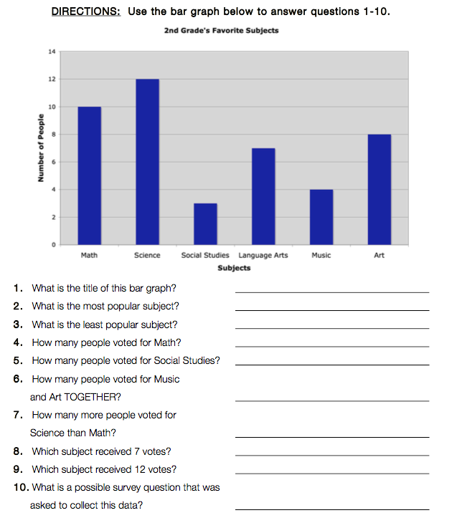**Name: __________________ Date: _____________**

**Name: _________________ Date: _____________**

|  |  |  |
| --- | --- | --- |
| **Coin Flip** | **Tally** | **Total** |
| **Heads** |  |  |
| **Tails** |  |  |
| **Total** |  |  |

**Directions:** In your group, each person will flip a coin 15 times. While one person is flipping the another should be recording until everyone has had a turn to do everything. Keep track on a tally chart and then make a bar graph to show your data. Remember to have titles, and labels. When finished answer the questions on the back.

**Name: __________________ Date: _____________**

1. **What showed up more often heads or tails?**
2. **What is the probability of getting heads or tails? Equally Likely or Not Equally Likely?**
3. **Does your bar graph show an equally likely chance to get heads or tails?**
4. **How many times did your group flip a coin altogether?**

**Spinner Game**

**Standard: Grade 3:** Data Analysis: Collect, organize, display, and interpret data. Use labels and a variety of scales and units in displays. 3.4.1.1 Collect, display and interpret data using frequency tables, bar graphs, pictures graphs and number line plots having a variety of scales. Use appropriate titles, labels and units.

**Launch-** **Day 1:** Start the lesson by a spinner on the overhead. Use a spinner that shows only two equal choices. Ask the class which option would be more likely to get spun? Answers should be they are both equally likely. Then ask them what they think the best way to keep track of what you had spun would be? (Hopefully having already taught about tally charts that would be the answer.) Spin the spinner and show them how to collect the data on the tally chart. Tell them that today they are going to look at a tally chart in a group and decide what the spinner would have looked like, and then they are to make a bar graph. (Hopefully they will have been reading bar graphs before this lesson – this would be the first time making a bar graph.)

**Day 2:** Review what was talked about the previous day by doing another whole group lesson with a spinner that has unequal pieces (2 or 3 pieces). This time do the spinning with the class watching and predicting what will happen when the pieces are not equal. Remind the class importance of correctly labeling a bar graph with a title and the two sides. Tell them that today they are going to be working with a different group and new information.

**Day 3:** Discuss all the important information learned in the past two days let them know that today they are going to take what they have learned about tally charts, spinners, and bar graphs and work on it independently.

**Explore- Day 1:** Group the class in groups of 3 to 4. Hand out 1st spinner game and have them complete using the tally chart, spinner circle, and making a bar graph.

**Day 2:** Group the class into new groups of 3 to 4. Tell them that they are going to use a tally chart to make a bar graph and a spinner circle using different information than the day before.

**Day 3:** Today the class will be working on a page by themselves to show understanding of what was worked on the previous days.

**Share- Day 1:** Have different groups share what they had made for a bar graph and spinner circle. Discuss the different ways of bar graphs and talk about things that maybe were forgotten and need to be included next time.

**Day 2:** Have the groups swap with another group and look over each other’s to see if they notice anything different. Then discuss as whole group.

**Day 3:** Ask students how they translated the tally marks into a spinner and graph. Discuss what was easier working independently versus working as a group.

**Summarize-** The TOTAL number of tally marks is how many partitions are on the spinner and the number of tally marks for each category is how many sections of the spinner represent that event. Each day talk about why these things are important. How tally charts are helpful for keeping track of things that have happened. How bar graphs are helpful in showing what happened in another way.







**Line Plots**

**Standard: Grade 3:** Data Analysis: Collect, organize, display, and interpret data. Use labels and a variety of scales and units in displays. 3.4.1.1 Collect, display and interpret data using frequency tables, bar graphs, pictures graphs and number line plots having a variety of scales. Use appropriate titles, labels and units.

**Launch- Day 1:** Have your tally chart, pictograph, and bar graphs of birthdays up front so they can see the information. Tell them that they are going to learn yet another way to organize information. Talk to them about how with tally charts, pictographs, and bar graphs you can compare different colors, animals, foods, etc. With a line plot, you can look at one thing and organize how many times (frequency) it occurs. Ask we can organize our birthdays on a line plot?

**Day 2:** “Your teacher wants to know what number will be rolled the most.” Today they are going to be working with rolling a die and recording their data in a tally chart. Then they will need to put their data into a line plot.

**Explore- Day 1:** Discuss different things you could make a line plot for. Pick one of the ideas that were brought up and make a line plot for the students to see how data is organized on a line plot. Show them things that must be included with a line plot (title, a number line, and X’s to show data). Give them time to work on answer questions by reading a line plot.

**Day 2:** In groups of 2-3 have the students have a six-sided die. Each group member will roll the die 30 times (they should both have a turn recording and rolling) and then they should combine their results on a tally chart. After they have all had their turns and recorded their data each group member needs to make a line plot of their data including the required pieces (title, a number line, and X’s to show data).

**Share- Day 1:** Come together and talk about what was being shown on this line plot. Go through the questions together to see how they did with reading a line plot.

**Day 2:** Have each group share their data. After each group ask them what number is rolled the most? Keep a visual record of what each group says will be rolled the most. (Hopefully each group had different results.) Ask what we can do to only get one answer of what number is rolled the most? (Combine all the information onto one line plot.) Relate to the Spinner Game and discuss what the probability of getting each number on a die is.

**Summarize-** Compare the tally chart, pictograph, bar graph, and line plot. Have students take a vote on which way they like better to have information organized. Get the point across again that everyone will feel more comfortable with different ways of having information organized and that line plots cannot be used to compare data, but is used to show one piece and how many times something occurs. Also relate to probability – point out what our combined results from day 2 had for experimental probability.

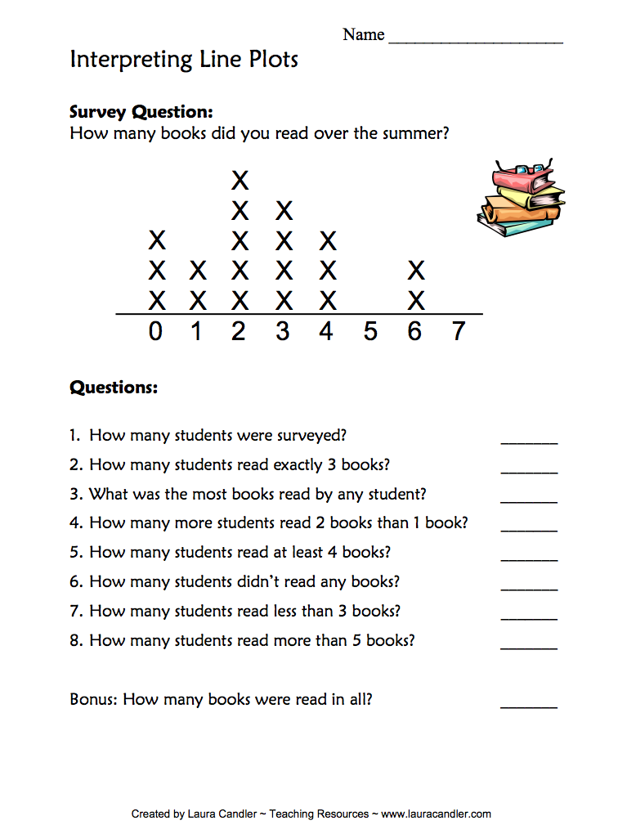

**Name: _________________ Date: _____________**

**Directions:** Each member of your group should roll a die 30 times. While one person is rolling a die the other should record your information on a tally chart. In the space below the tally chart show your data on a line plot. Include a title, a number line, and X’s to show your data on your line plot.

|  |  |  |
| --- | --- | --- |
| **Number Rolled** | **Tally** | **Total** |
| **1** |  |  |
| **2** |  |  |
| **3** |  |  |
| **4** |  |  |
| **5** |  |  |

**M & M Graphing**

**Standard: Grade 3:** Data Analysis: Collect, organize, display, and interpret data. Use labels and a variety of scales and units in displays. 3.4.1.1 Collect, display and interpret data using frequency tables, bar graphs, pictures graphs and number line plots having a variety of scales. Use appropriate titles, labels and units.

**Launch-** Show the class a bag of fun size M & M’s and ask how many kids like to eat M & M’s? Review all the different things we have been learning about probability, tally charts, pictographs, bar graphs, and line plots. Ask if they think it will be equally likely or not equally likely with the number of colors in their M & M bags? Will it be likely to pull out a pink M & M? Will it be likely to pull out a blue M & M? Record these predictions on the board so you can come back to it after they explore & share. Today their job today is to use the fun size M & M’s to fill in a tally chart, bar graph, and pictograph. Let them know not to eat their M & M’s until they have completed their graphing page.

**Explore-** Each student should have one work page of M & M Graphing, a pencil, and a fun size bag of M & M’s. Allow them time to work on completing their graphing page. Once they have finished they can enjoy their M & M’s and answer the questions on the back.

**Share-** Have the students either share with the overhead or stand in front of the class their graphing page. While students are sharing combine their data onto one bar graph so they can see what the entire classes data looks like combined.

**Summarize-** Discuss why someone would need to show how many M & M’s using a tally chart, bar graph, or pictograph. Once their bags were opened were the colors equally likely or not equally likely? Were they right with their predictions about pink and blue M & M’s? Why can’t we show this data on a line plot? Is there a way to show some data we collected on a line plot? Which method did they prefer to show their information and why? Which method shows the information more easily for lots of people to understand? Remind the students how graphs can be used to show all kinds of data from doing experiments to taking surveys.

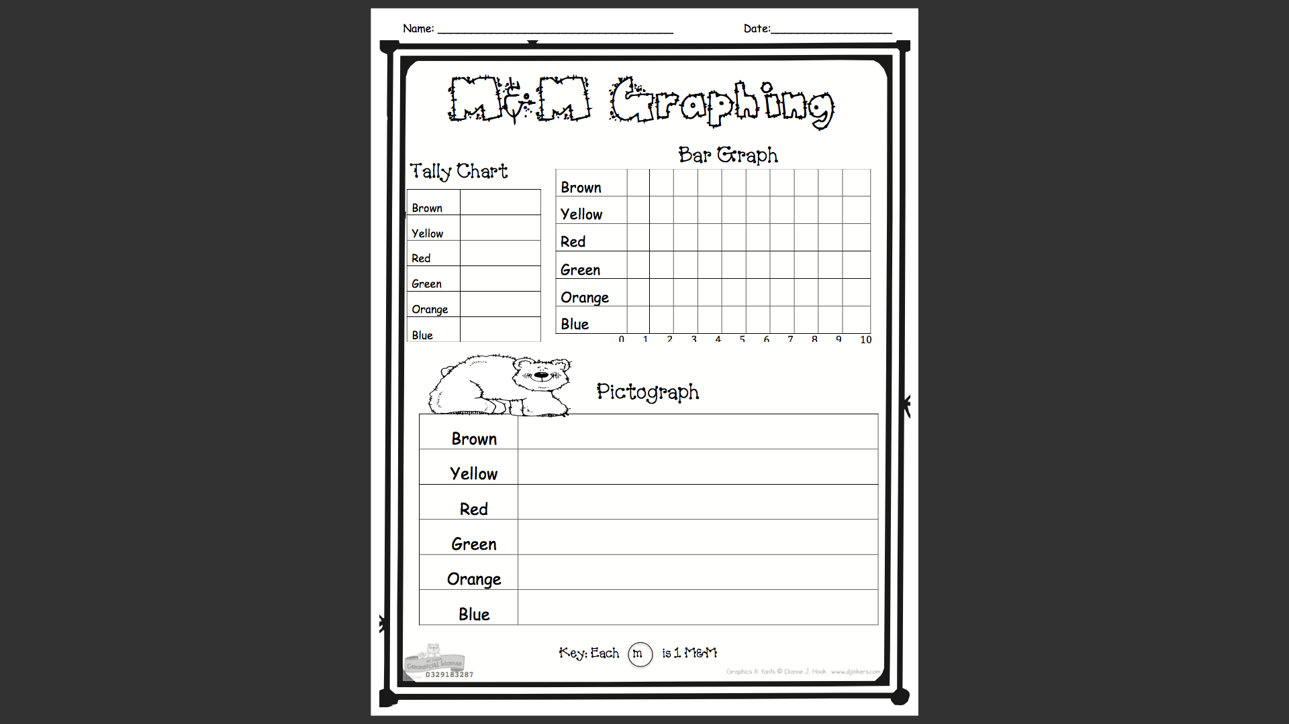

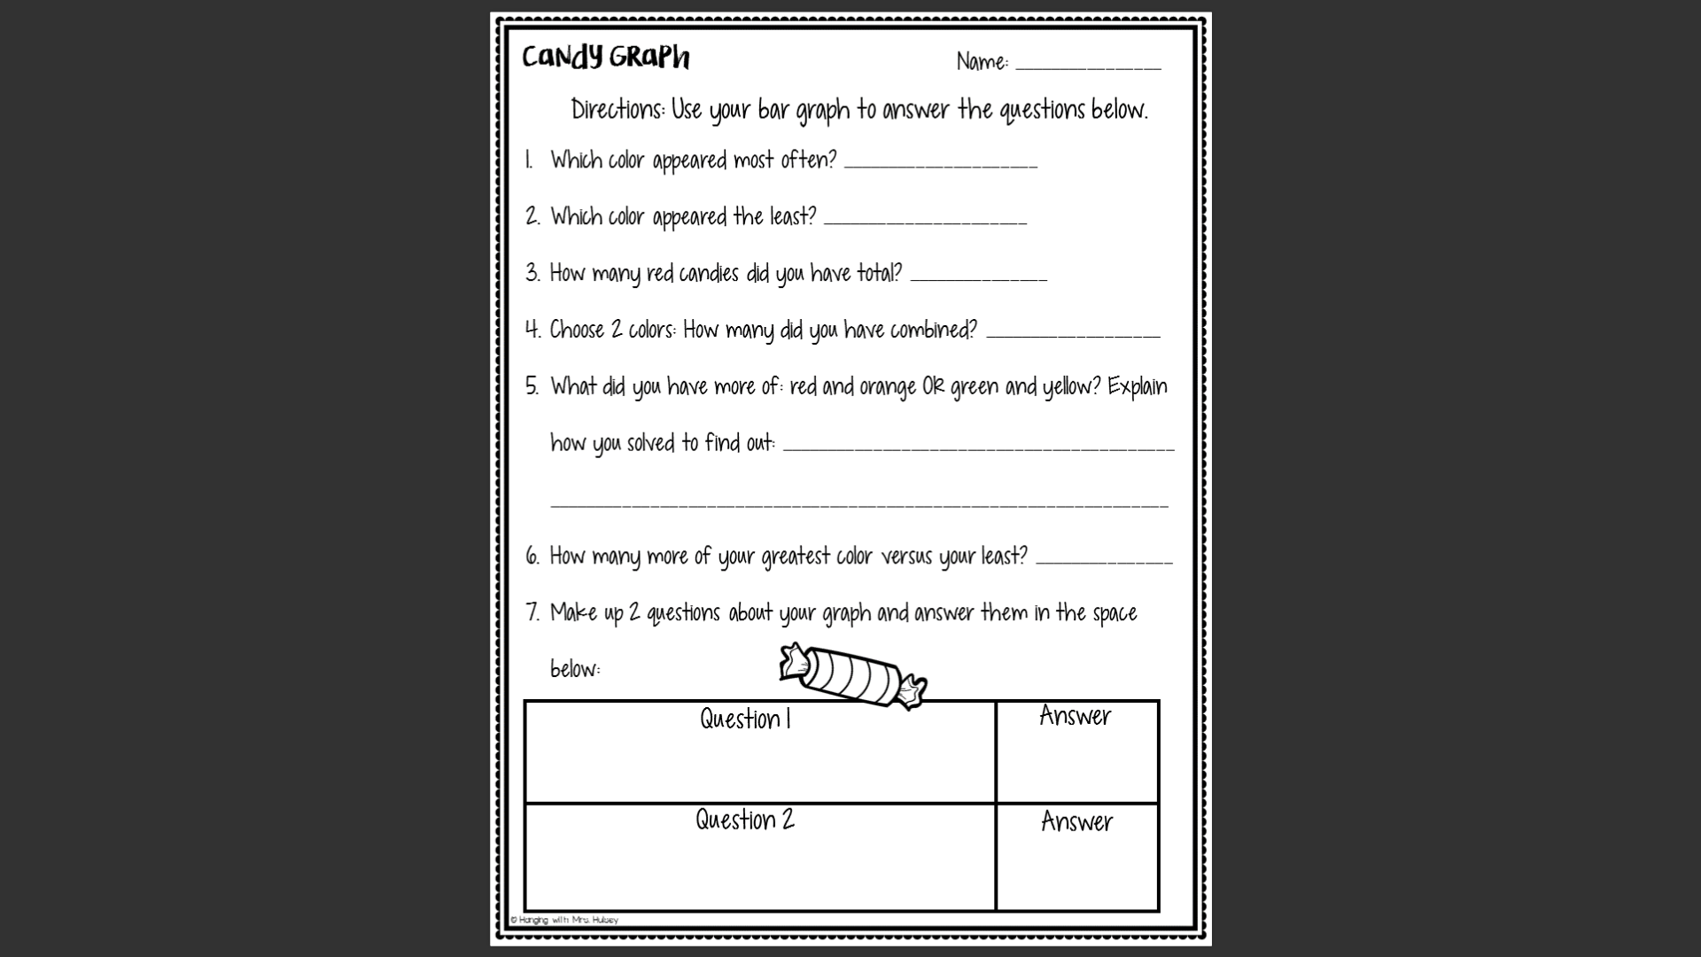

**Prodigy Day**

**Standard: Grade 3:** Data Analysis: Collect, organize, display, and interpret data. Use labels and a variety of scales and units in displays. 3.4.1.1 Collect, display and interpret data using frequency tables, bar graphs, pictures graphs and number line plots having a variety of scales. Use appropriate titles, labels and units.

**Launch- (**Students may or may not have used prodigy before depending on your classroom.) Today we are going to play on prodigy! Remind them that they need to be actively playing the game not just wandering around exploring. They should be completing tasks and battling their classmates! (Teacher should have set up an assignment of data relationships based upon what we have been learning so that those are the questions being asked of the students.)

**Explore-** Each student will be at a computer with their login information for the prodigy website. They can play the game, answer questions, and battle their classmates!

**Share-** After computer time is up go back as a whole group and discuss what kinds of questions they were answering as they were battling. (From the teacher account, you can decide if you want to share how they did or not. You will be able to see how they did and decide if you are ready to take the post test or if there is something that needs to be readdressed.)

**Summarize-** Discuss all the things they have been learning about collecting, organizing, displaying, and interpreting data. Also discuss what they have learned about probability – is everything always equally likely? Relate to real life if possible.

**Pre/Post Test**

**Standard: Grade 3:** Data Analysis: Collect, organize, display, and interpret data. Use labels and a variety of scales and units in displays. 3.4.1.1 Collect, display and interpret data using frequency tables, bar graphs, pictures graphs and number line plots having a variety of scales. Use appropriate titles, labels and units.

**Launch-**

**Pre-Test:** We are going to start learning about collecting data and how to organize data. Before we start learning about how we do this I need to know what you already know! We will take a pre-test. Answer what you can if there is something you don’t know how to do you can skip over it.

**Post Test:** I want to see what you have learned about collecting and organizing data. Just like we did before we started learning about collecting and organizing data we are going to take a test. I want to know what you have learned. Take your time and do your best!

**Explore-**

**Pre-Test:** They take the assessment – allow students plenty of time on the pre-test to complete their work. When the class is finished or you feel they have spent enough time trying collect all of the pre-tests.

**Post Test:** They take the assessment – allow students plenty of time on the post test to complete their work.

**Share-**

**Pre-Test:** Discuss what they think they will be learning about based on the test they took. Take a vote on if they have heard anything before.

**Post Test:** Go over test answers with students and see how they felt about it. Check for understanding.

**Summarize-**

**Pre-Test:** We will start tomorrow with an activity!

**Post Test:** You can all collect and organize data now! Reinforce that each person will prefer to see data organized in a different way and that is okay.

